[Date]

STUDENT ID:

TUTOR NAME:

MOBILE APP DEVELOPMENT

# **CONTENT:**

**CONTENT:** 1

**PROJECT PURPOSE:** 1

**EXPENSES APP ANDRIOD:** 1

**INTRODUCTION:** 2

**PROJECT GOALS:** 2

**Motivation of Projects** 2

**Statement of Problem:** 3

**Scope of project:** 3

**Methodology in App Creation used** 4

**Stage of Planning** 4

**Stage of Research** 4

**Phase of the Concept Prototype** 5

**Construct and testing** 5

**Step of Implementation** 5

**Description of the Project and tools used.** 5

**SDK for Android** 5

**Language for Java Programming** 6

**Android API by Google Locations** 6

**Technology devices Involved.** 6

**Inquiries AND Problems OF Execution** 6

**Functional and Non-functional Requirements:** 6

**CONCLUSION:** 11

**REFRENCES:** 12

# **PROJECT PURPOSE:**

# **EXPENSES APP ANDRIOD:**

EXPENSES MANAGER is an application for Android. It records your own spending, family expenses and accidental costs. This resembles a modern-day expense in your flexible day book. This programmed allows you to chart the subtle elements of your everyday expenses, arbitration points of concern, total summary, thorough monitoring, and periodic costs. Each data is placed in the database and the consumer and their family will retrieve it.

# **INTRODUCTION:**

We are now switching to innovative technologies as creativity evolves. This programme is one of them. The key purpose of this programme is to automate it instead of manually doing it. In those days, we maintain a cost-day book to monitor our day-by-day expenses, seasonal costs, and define and physically count the financial schedule. In any event, the bulk of us are now using advanced smart phones for a few days and the most recent rendition of android mobiles is a standout of the most used. Here, we can track our expenses, refresh data and make it computerized by using this programme. The smartphone application, app, marketplace has been a major industry in recent years. The use of smartphones and tablets has evolved to virtually eradicate the use of "phones and tablets" (phones that are unable to handle sophisticated tasks such as a smartphone). Although there are still many of these remaining, developed countries where mobile internet connectivity (a smartphone requirement) is not common are the main demand for them. Companies are also forced to create a way of accessing their data on these phones to support this huge mobile market, be it an allow effective or a web application. There are several platforms, but the smartphone room is mainly occupied by a few iPhone and iPad models running.

IOS and several hundred thousand Android-operating smartphones. Applications designed for one of these platforms are not consistent with the other platform and will entail porting to various versions of the OS, making it an undertaking to improve them so there would be at least two versions of the OS. Codebases for upgrading and maintaining.

# **PROJECT GOALS:**

* Autocomplete search to create an application that can import a menu based on Google. For instance, the user can download McDonald's menu at McDonald's restaurant.
* To construct an application which is sufficiently easy and accurate to keep track of
* Costs and budgeting.

To create an application that will satisfy a wide variety of specifications for an optional input process. Just ex. E.g., Users can use a voice order when driving a vehicle.

* The user can save even more input options, such as image, speech, into the application.

# **Motivation of Projects**

The need for the cost application ranges greatly from adolescent to senior customer, so long as they do continue to use currency, they need to provide an application to store and manipulate their expenditures and budgeting.

Most of the current programme is only in text form and the user must input the data manually, which would frustrate the user due to the precision of the results. The monitoring of the geo-location would attempt to solve their issue, automatically with the address key as well as the locations they have been.

Another problem will be the current system without distributed communication input, which creates insufficient power to manipulate the data. The user can input the image as a record and does not have to enter any data at all. Another problem will be fixed is the title or principal for users to enter when they are in walking or driving condition, they could be able to use voice recognition to input the expenditure application information.

To provide more feedback method is to make consumers happier to use the programme and to help them specifically manage their expenses or maybe keep track of their target, to make more benefit for company users and workers who need to make refund records. In the expense’s application, receipts are conveniently saved, and the data is collected as they need it.

# **Statement of Problem:**

* There are several kinds of budget spending programmed now, but the existing application does not have such a feature to document where they spend their money and use the tool. There is, however, an acute need for such a method to track more comprehensive and reliable budget spending.
* The input of information is so difficult, the individual spending needs to be accurate, and the consumer needs to write more data, so it takes time and takes time.
* Drawbacks. Therefore, it was appropriate to migrate to a simpler and more automated fill-up system.
* The way they needed for inputs is very important when there is a situation where users are inconvenient to type the results. The type of input is then necessary to replace the conventional input form to provide an alternative. One of the easiest ways to replace handwriting is speech recognition.
* The conventional cost framework can restrict only input text for the user, but for more   application must be able to enter further options, such as camera entry, speech entry and QR-code entry, for the implementing digital portion.

# **Scope of project:**

1. User can view and generate report of expenses .

2. If available, the direction will be taken by the cell phone network operator and the GPS signal location.

3.A framework of application budgeting with simpler input method and more options such as image, voice, and barcode.

# **Methodology in App Creation used**

There have so many methodologies as the device implementation life cycle (SDLC), the technique wants to build Geo-Location Expenses system is throw away prototyping. The explanation for the throwaway version is that the final throwaway prototype is cost-effective and also ideal for unfamiliar applications such as speech recognition computer code, QR code detector, as well as Geo-location and cloud databases. In comparison, the development of throwaway prototyping to assist this project to validate any feature performs well and easily as it hits the final application of the method.

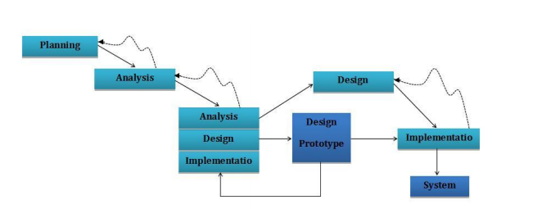

Starting at the planning level, the step of throwaway development and testing production work then starts by analytical state, the proposal must be split to sub-function of analytical state analysis to independently construct and evaluate the prototype. Each sub-function must repeat the same procedure as the whole function. After finishing all the sub-function, if there is no question, the developer needs to create a build and validate and then start implementing the framework. If there is no problem with execution, the final method is used.

# **Stage of Planning**

Next, an analysis focused on the present system and a literature review to classify the new system. Application definition that establishes and often defines the issue that the actual problem is software that is present.

Describe the problem and the objective.

How to make a new scheme out of the present one

# **Stage of Research**

In the research process, the project wants to figure out how the device can recognize the voice for voice recognition, and how the QR code is identified by the cell phone camera. In addition, I must remember the Geo-location from the actual user location, how the programme will interface with certain APIs, such as the Google Map API, the firebase server database relation used in the application framework. The Gantt diagram and UML diagram are then built based on the project specifications.

# **Phase of the Concept Prototype**

The concept design stage, based on the analytical stage, transforms the criterion into a logical structure. Such as the Visual Framework UML diagram. Plan the interface to interact better with each feature and to achieve better performance when designing it.

# **Construct and testing**

Which is the step before the phase of implementation; it moves from the logical concept to the real framework and checks the prototype module. This is perhaps the longest path in the life cycle of application development. Unit testing, integration, and system testing, testing of the system, approval testing is used in the testing stage.

# **Step of Implementation**

In addition, this step transforms the current system configuration into practices, and this system must be tested if it is going to operate after integration. In the integration process, whether there is a flaw or problem, they will attempt to correct it as quickly as possible.

# **Description of the Project and tools used.**

This project aims to include a smartphone device with a perfect Expenses Geo-Location framework. The scheme of expenditures would equate the object that the consumer reports or pays with the location base. The keep monitoring cost scheme uses the feature on smart phones, including the GPS location signal and network, to calculate the user's location and keep track of the user's purchased object. When the user begins the smartphone application, the location of the user will be determined by the GPS signal and the restaurant or popular locations will be queried from the database provided by the Google Places API.

The rather unique features of the Geo-Location Expenses framework allow the user to display autocomplete on the location restaurant menu, depending on the location search by Google.

The Expenses programme transfers the URL to the mobile browser when there is a menu available for the restaurant, the menu is activated, and the user can see all the food inside the website. The customer will select from the menu to make the website think of an application. When it is sent, the customer can see the order number and the order information. Users will restore the data that they have uploaded and save in the local android database while returning to the Geo-Location Expenses system.

# **SDK for Android**

The Android SDK, which can be freely accessed from the main Android website, enables designers with the requisite API libraries and tools to create, test and debug Android applications. In addition, the Android library provides provisions for the use of multitasking, drag - and - drop and swiping between windows. Therefore, if the Application software for this project is to be created, it is crucial to use this Android SDK. Because various computer platforms need different types of SDKs, prior to uploading and installing an SDK, proper compatibility tests and device specifications should be carried out.

# **Language for Java Programming**

Most of the essential features and frameworks are built using the Java language in the Expenses with Geo Position project. The explanations for using the Java programming language are that most Android devices run on Java systems today. Since Android implements the open-source framework, accessible code samples and supports from various lenders or website, can be easily accessed therefore, finding, sharing as well as the development of solutions to those problems can be easily performed.

# **Android API by Google Locations**

The Google Places API is a tool that returns information about places that users already visit if users include the API in their application. About the API using HTTP requests to construct geographical areas or famous points of interest. In September 2010 Google released Position Sites for more than 50 million locations around the world last September (John, 2010), the key concept is to help users make more educated choices about where to travel, restaurants, hotels, dry cleaners, or bike shops, and areas such as museums, parks, and playgrounds.

# **Technology devices Involved.**

* Browser, Notebook/Desktop (visual studio ) machine with asp.net enabled.
* Mobile handsets (Android 4.2 and above)
* -Cell phone with feedback for video
* -GPS mobile telephone with signal
* Router (Wi-Fi, Internet)

# **Inquiries AND Problems OF Execution**

The issues and complexities in designing this application are.

1. Integrating applications with very few APIs. Just ex. E.g., Recognition of Google Voice, Google Places API

2. Deal with the server menu that can be identified and picked depending on the position of Google locations, download menu to view with the browser in the programme.

3. It is not familiar with the Android database and needs higher ERD levels to be introduced.

4. System of costs due to varying inputs and the need for correct description estimation. Using flurry, for example, to produce summary data and study.

5. The programme requires the use of devices including the GPS signal, the internet and hardware camera for scanning QR-code and photo capturing camera.

# **Functional and Non-functional Requirements:**

Under situations, those specifications define device behavior and provide the product functionality and functions that must be applied to the solution by web & software developers. These criteria should be specific both for the production team and stakeholders.

The list of practical requirement examples contains:

* Codes of Company
* Corrections, updates, and cancellations of purchases
* Administrative Positions
* Authentication Of
* Authorization rate
* Tracking Audit
* The External Interfaces
* Requirements for Qualification
* Requirements for Reporting
* Historical Info

They can plan most of the specifications in written form if the project uses Agile technique. Even, the team should imagine them to show those specifications more explicitly.

In the following types, the functional specifications may occur.

Functional specifications are software functionality or functions that must be introduced by developers to allow users to complete their tasks. So, both for the development team and the stakeholders, it is essential to make them clear. Functional specifications typically characterize device actions under circumstances. For example:

If they choose to credit a released invoice, a search feature helps a user to hunt between multiple invoices.

Here's another easy example: I want a sofa as a visitor that I can stay overnight on.

In the standards specification (SRS) text, functional and nonfunctional specifications can be formalized. (Read our post on that topic to learn more about programme documentation.) The SRS includes explanations of features and functionality that must be supported by the product. Constraints and assumptions are also specified in the paper. The SRS may be a single paper that expresses technical specifications or may complement other programme documents such as usage accounts and cases of usage.

Before the implementation kick-off, we do not advocate writing SRS for the whole solution, but before actively constructing it, you can log the specifications for any single element. You can upgrade the report until you obtain the initial user input,

Having the SRS accessible for all stakeholders is important. To organize the details and help people clarify it, you can also use models for visual importance. Link to them to encourage readers to locate the necessary details if you have specifications stored in any other paper formats.

Example: If you want to see an actual text, download this example of the SRS produced at Michigan State University, which contains all the above, in addition to providing use examples to explain aspects of the product.

A functional necessity in software engineering determines a device or component. It defines the tasks that must be done by a programme. Nothing but inputs, their actions, and outputs are a function. It may be a measurement, data processing, business method, user interaction, or some other feature that determines what is likely to execute a system's purpose.

Requirements for usable applications allow you to capture the system's expected actions. This activity may be represented as tasks, resources or assignments, or whatever mechanism is expected to perform.

A graphic document that shows how dynamic systems break down into their smaller substances is a functional evaporation or WBS. To allow for an individual review of each component, WBS is an efficient solution. WBS also helps catch the project's entire image.

Prototype software is an umbrella term for various types of early-stage deadlines that are intended to illustrate how specifications could be enforced. Prototypes help fill the differences in vision and encourage partners and teams to illustrate complex product areas in production. Prototypes typically represent how the solution works and provide details of how consumers communicate with it to carry out their activities.

Ultimately, you want to deliver the item the customer ordered. The main way in which the consumer expresses their expectations to the team is practical specifications. They keep us working in the same direction on the project team. The result is likely to miss the target without providing an agreed practical specifications manual to specifically describe the scope. It is certainly a challenge to initially have the incorrect scope, but it also causes other problems. The timeline is expanded to address the scope, and the cost increases. The client does not have the time and resources to correct the flaws, so they just tolerate them and believe the product has defective products.

However, not all reach is similarly important. The client usually has both needs and desires. They can ask for a reduction in reach after seeing the cost estimate. Scope cutting activities are mostly based on non-functional criteria. The expense can be easily guided by excessive non-functional requirements, thus inadequate non-functional requirements contribute to poor user experiences. Realizing the distinction between practical and non-functional requirements would assist both the consumer and the seller to fully grasp their needs, leading to greater refining of variety, optimized prices, and eventually a happier customer.

Nonfunctional specifications define how a device must operate and its flexibility must be restricted. This type of specifications is also known as the quality characteristics of the system. Let's take a close look at traditional specifications that are non-functional.

**Usability,**

Usability determines how challenging it can be for a customer to understand the device and use it. It is possible to determine usability from multiple points of view:

**Security:**

Protection specifications guarantee that the device and its stored data are secure against unwanted access to the system. It considers multiple layers of authentication and authorization through various user functions. Data protection, for example, is a security feature that defines who can make, see, copy, modify, or erase information. Defense also requires protection against ransomware attacks and viruses.

**Dependability**

Reliability determines how probable it is for a given amount of time for the programme to function without loss. Reliability declines due to programming errors, hardware faults, or issues with other elements of the system. You may count the percentage of operations that are performed successfully to calculate programme stability or log the total time the machine operates before crashing.

**Performance**

Performance is an element of consistency that represents the system's sensitivity to different user experiences with it. Bad production adds to negative customer experience. It also endangers device security when it is overwhelmed.

**Availability**

Availability is determined by the time that the functionality and resources of the device are accessible for use in all operations. So, this parameter is specifically influenced by planned maintenance times. And how the effect of maintenance can be reduced is necessary to identify. The team needs to identify the most important elements of the framework that must be always accessible while writing the availability specifications. User alerts can also be prepared if the device or one of its components becomes inaccessible.

**Scalability**

The criteria for scalability explain how the device could expand without having a negative impact on its efficiency. This implies servicing more people, collecting more information, and carrying out more transactions. Scalability has repercussions for hardware as well as applications. For starters, by adding storage, servers, or storage space, you can economic consequences. You can, on the other hand, compact files, use algorithms for optimization, etc.

# **CONCLUSION:**

**PROJECT OVERVIEW:**

In conclusion, the Geo-Location Monitoring Expenses Project will be one of the beneficial apps that will help users save time by monitoring their profits and expenses. Users can produce more wealth with this application relative to non-users using this kind of application product. It just functions perfectly in terms of input, has multiple input types, and would thus not hinder the use of this programme for a longer time. In comparison, consumers are able to distribute their money to helpful fascinating sites, rather than wasting their money unconsciously on them.

In order to retain a powerful menu refresh, this project is categorized into two parts, which are a client-side framework and administrator as a server backup. Android's native framework serves as the server side, and the backend server is developed using PHP. The Google Places API plays a significant rule in accessing knowledge about wealth.

**OBJECT ARCHIVED:**

The application for Geo-Location Expenses had accomplished the 5 key goals mentioned earlier, enabling the user to keep track of the current location address while the user stored the application with an expense log. The second goal archive helps the user to navigate the menu display and choose within the menu. After making a list, the customer can get back what he/she has originally posted. The database of the Geo position often simplifies the collection of data in Expenditures by using autocomplete data produced by the application, e.g., time, date, and location of the customer. The fourth is, satisfying the vast spectrum of criteria, they will replay text with voice order or voice feedback as users are driving or walking. The last archive of items is capable of several inputs for the spending system.

**FUTURE IMPROVEMENTS:**

There are few proposals for this initiative in the future, and they can be improved.

1. The camera information can be used in the system of image processing, so the receipt taken by the camera can be translated into text and the total sum and definition of the expansion record can be created automatically.

2. Able to add a payment form to this current expense scheme. For e.g., if a PayPal payment is made, the record is immediately entered into the framework for Geo Location Expanses.

3. The order for extensions can also be applied to the latest promotion notice. This would be filtered by the extension of consumer locations spent, his/her favorite. The restaurant with promotion will provide a new feed prompt for the submission.

4. Geo-Location costs can also come with a contingency option for storage. For example, to mitigate data loss, user data may be hosted on cloud storage/drive.

5. In terms of potential security design, the Geo-Location Expenses Framework will be able to a password authentication such as Facebook login is implemented; this functionality will give users greater security trust.

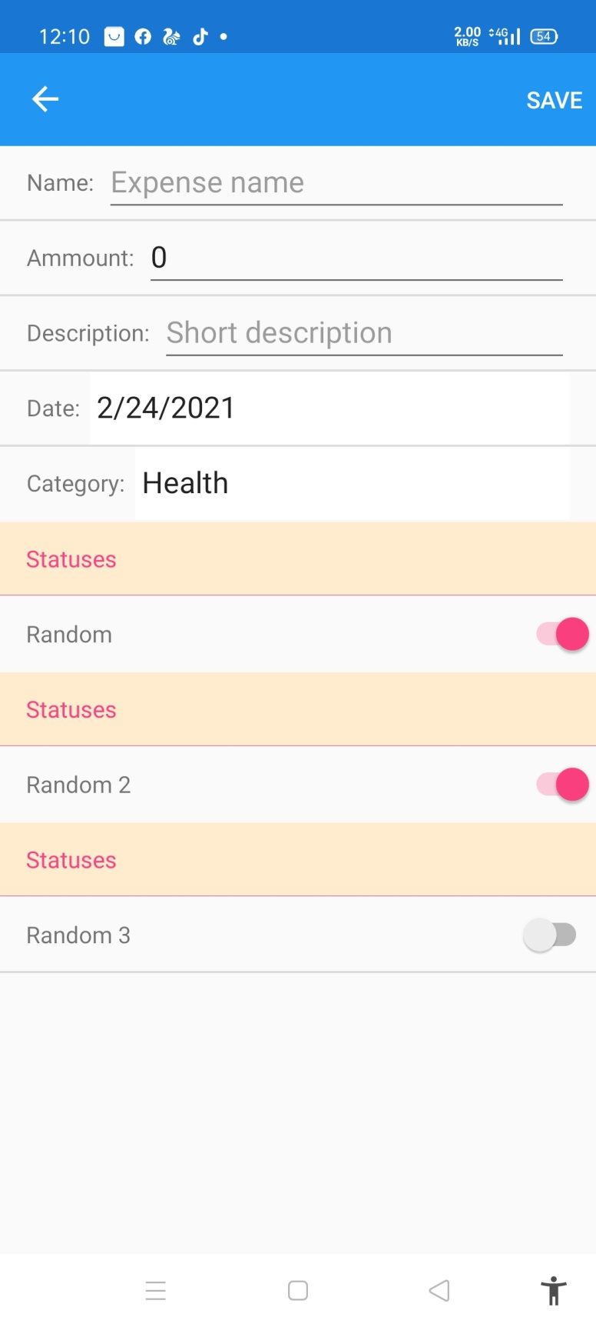

User can add expenses to their requirement

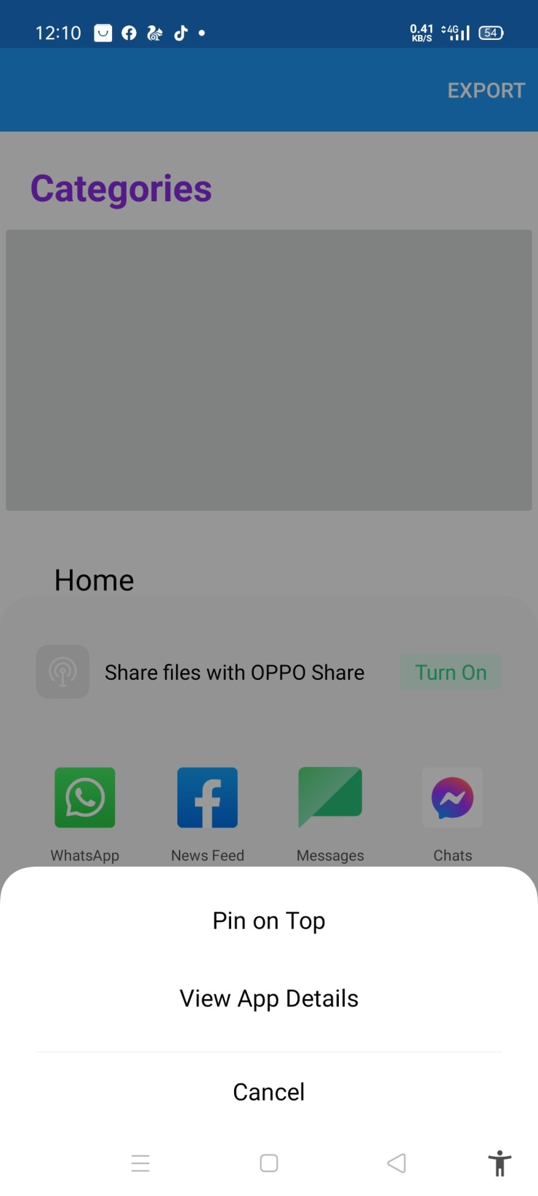

User can share report

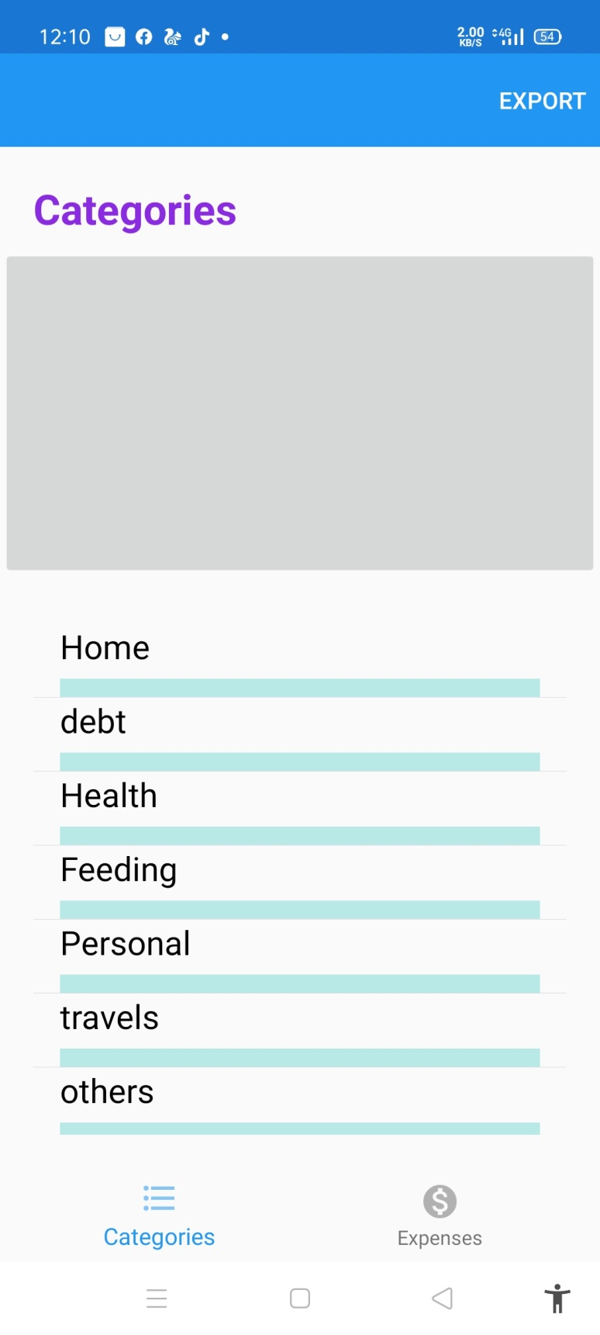

user can have different categories expenses

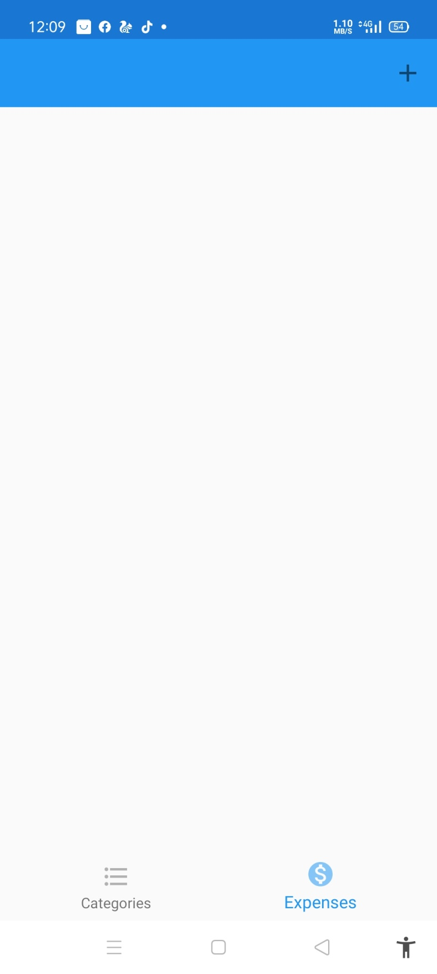

Add expenses from simple click

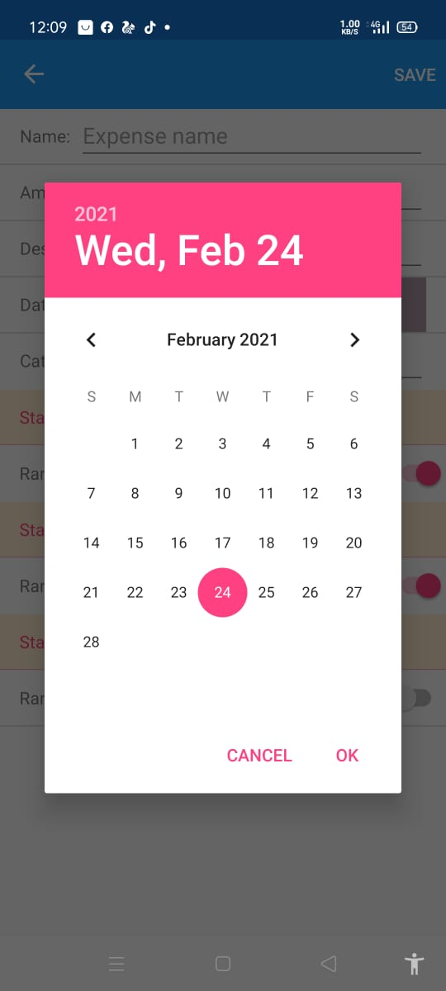

Manage expenses Via calendar

# **REFRENCES:**

* Joorabchi, M.E., Mesbah, A. and Kruchten, P., 2013, October. Real challenges in mobile app development. In *2013 ACM/IEEE International Symposium on Empirical Software Engineering and Measurement* (pp. 15-24). IEEE.
* Mota, J.M., Ruiz-Rube, I., Dodero, J.M. and Arnedillo-Sánchez, I., 2018. Augmented reality mobile app development for all. *Computers & Electrical Engineering*, *65*, pp.250-260.
* Willocx, M., Vossaert, J. and Naessens, V., 2016, May. Comparing performance parameters of mobile app development strategies. In *Proceedings of the International Conference on Mobile Software Engineering and Systems* (pp. 38-47).
* Inukollu, V.N., Keshamoni, D.D., Kang, T. and Inukollu, M., 2014. Factors influencing quality of mobile apps: Role of mobile app development life cycle. *arXiv preprint arXiv:1410.4537*.
* Zhang, M., Cheow, E., Ho, C.S., Ng, B.Y., Ho, R. and Cheok, C.C.S., 2014. Application of low-cost methodologies for mobile phone app development. *JMIR mHealth and uHealth*, *2*(4), p.e55.
* Barnett, S., Vasa, R. and Grundy, J., 2015, May. Bootstrapping mobile app development. In *2015 IEEE/ACM 37th IEEE International Conference on Software Engineering* (Vol. 2, pp. 657-660). IEEE.
* Willocx, M., Vossaert, J. and Naessens, V., 2015, June. A quantitative assessment of performance in mobile app development tools. In *2015 IEEE International Conference on Mobile Services* (pp. 454-461). IEEE.
* Jones, N. and Moffitt, M., 2016. Ethical guidelines for mobile app development within health and mental health fields. *Professional Psychology: Research and Practice*, *47*(2), p.155.
* Shih, F., Seneviratne, O., Liccardi, I., Patton, E., Meier, P. and Castillo, C., 2013, August. Democratizing mobile app development for disaster management. In *Joint Proceedings of the Workshop on AI Problems and Approaches for Intelligent Environments and Workshop on Semantic Cities* (pp. 39-42).
* Francese, R., Gravino, C., Risi, M., Scanniello, G. and Tortora, G., 2017, May. Mobile app development and management: results from a qualitative investigation. In *2017 IEEE/ACM 4th International Conference on Mobile Software Engineering and Systems (MOBILESoft)* (pp. 133-143). IEEE.